Download Files from Mr. York’s Laptop

We will often need large files in this class—hundreds of MB for programs and several GB for virtual machine images. If the entire class downloads individual copies of a large file simultaneously, it will use a lot of the school’s bandwidth. You can download them much faster from my laptop, using files I’ve already downloaded from the Internet.

# Map a network drive (from a Windows 10 computer)

To connect to the file share on my laptop:

1. Open File Explorer, right click “This PC”, and select “Map Network Drive”.  
   Graphical user interface, application, Word

   Description automatically generated
2. Enter the following share location.  
   \\JohnLaptop\CyberPatriot  
   Note: the “slashes” are “back slashes”, the key above the Enter key. The one that is shift-question mark is a “forward slash.”  
   Check the box, “Connect using different credentials”, and click “Finish”.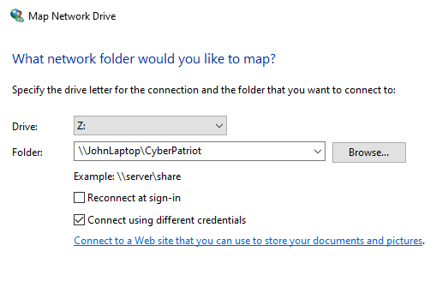
3. Enter svgs as the username and get the password from your instructor. Click “OK”.  
   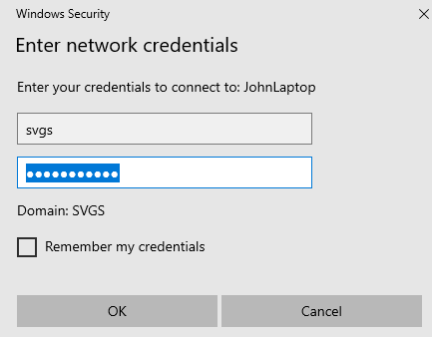
4. You should see a list of files in the CyberPatriot share.   
   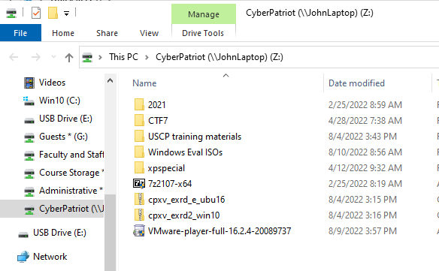
5. Drag the file you need to your desktop.